Assignment D
- Display all employees who have MongoDB skill
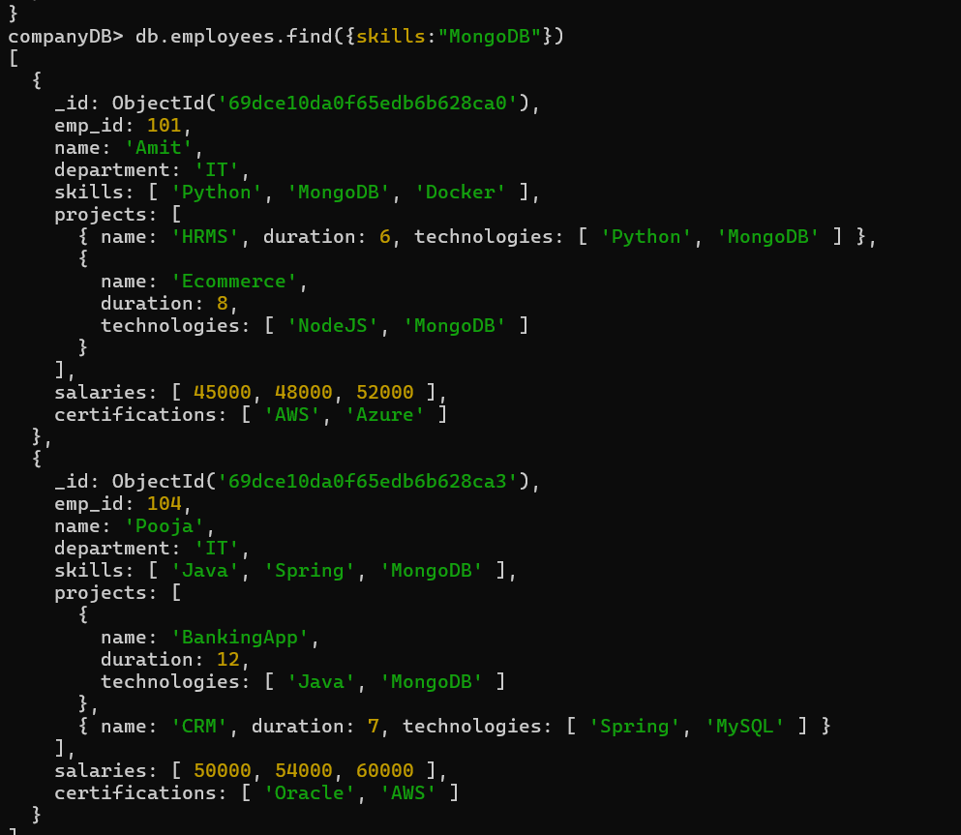

- Find employees having both Python and MongoDB skills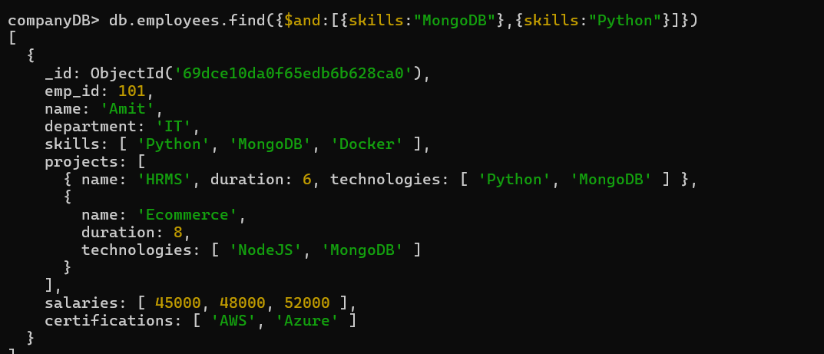

- Display employees with more than 2 skills
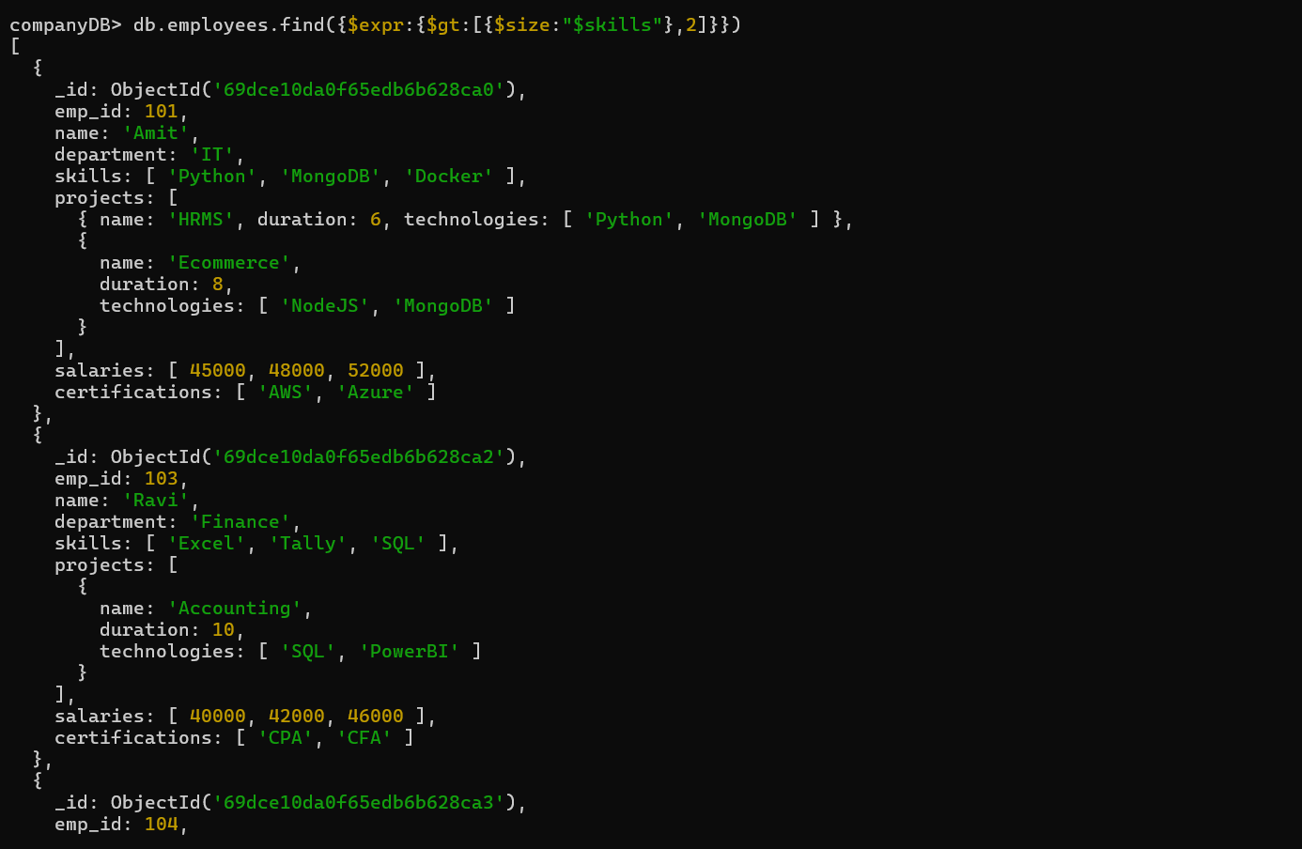
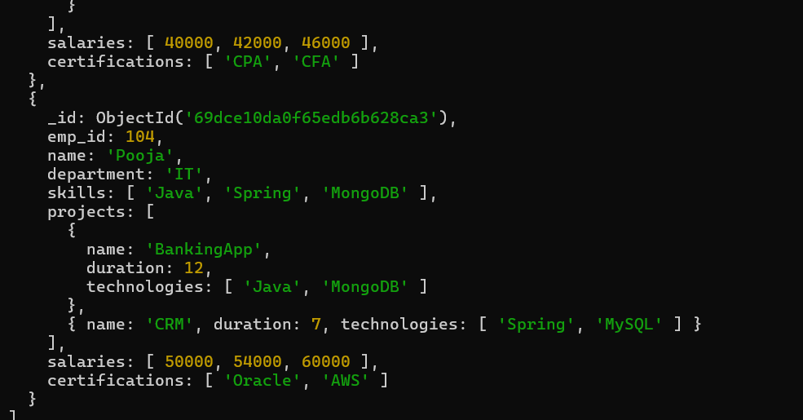

- Add a new skill "Kubernetes" to Amit
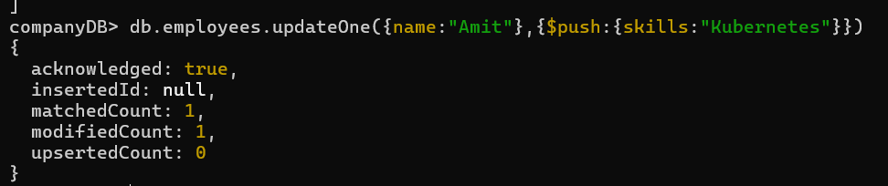
- Add multiple skills to Pooja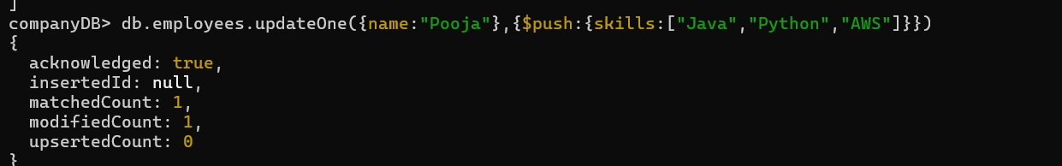
- Add a certification only if not already present
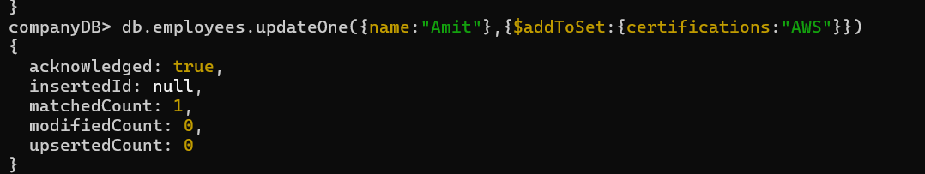

- Remove "Docker" skill from Amit
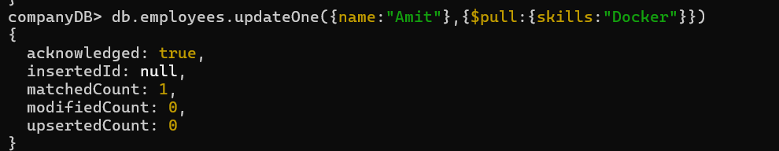
- Remove multiple salaries less than 45000
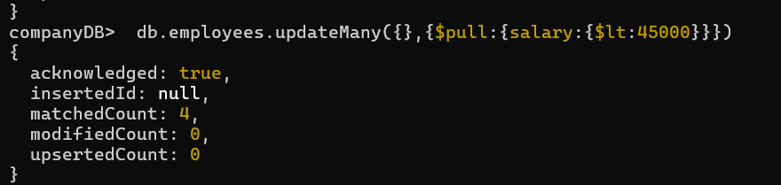
- Find employees who worked on MongoDB projects
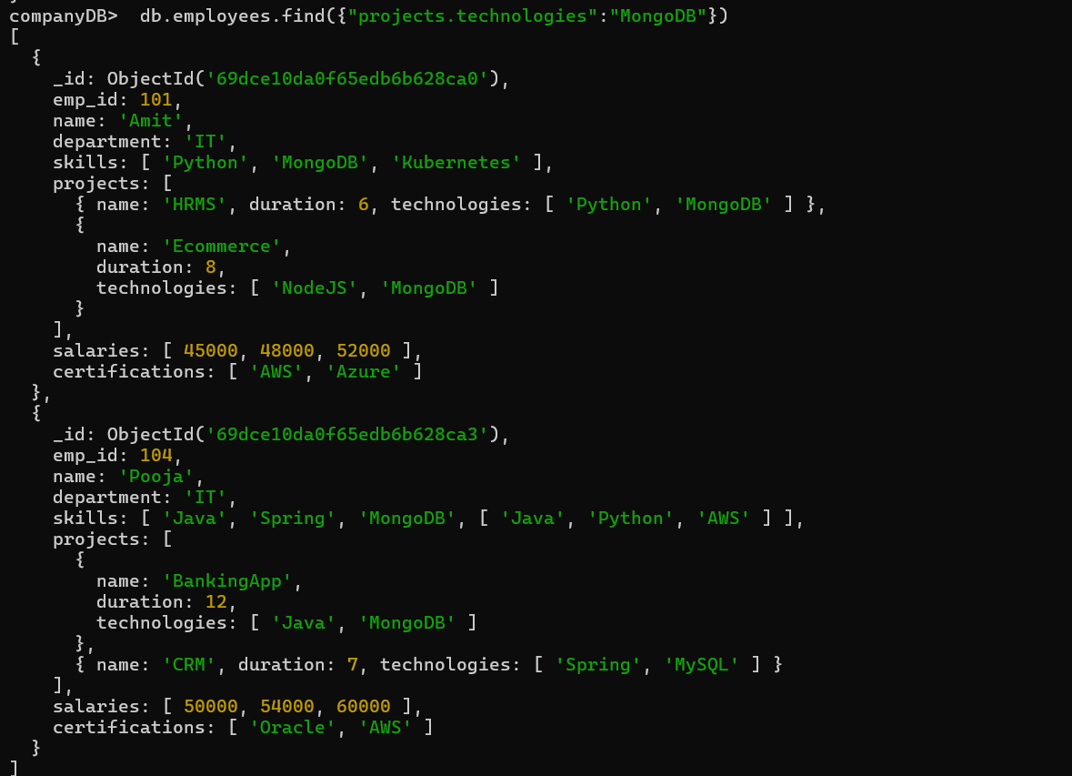
- Use $elemMatch to find project duration > 6 using MongoDB
--Topic not covered
- Count number of projects for each employee
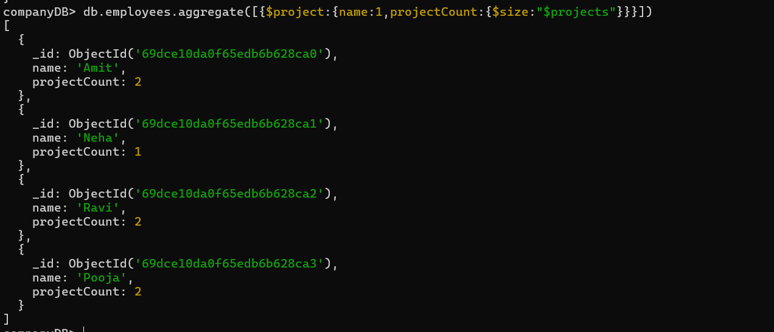
- Unwind skills array
--Topic not covered
- List unique skills across company
--Topic not covered
- Find employees with salary greater than 50000
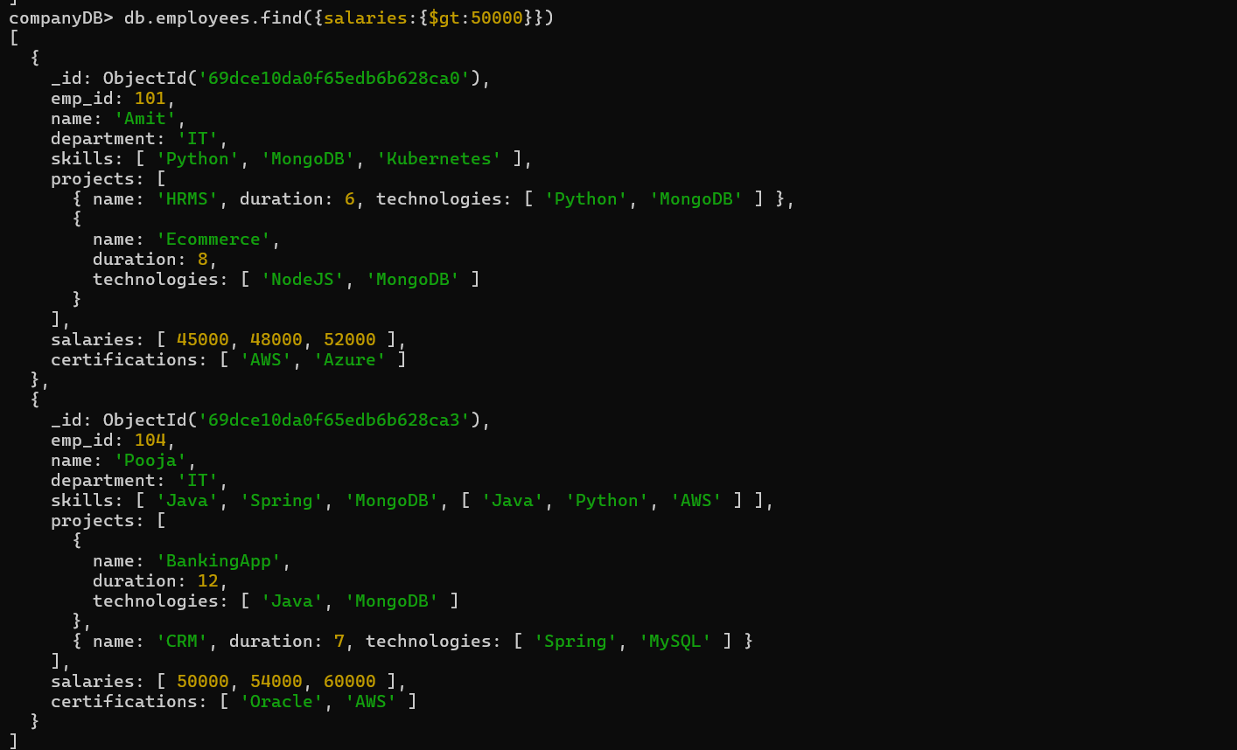

- Find employees with exactly 2 certifications
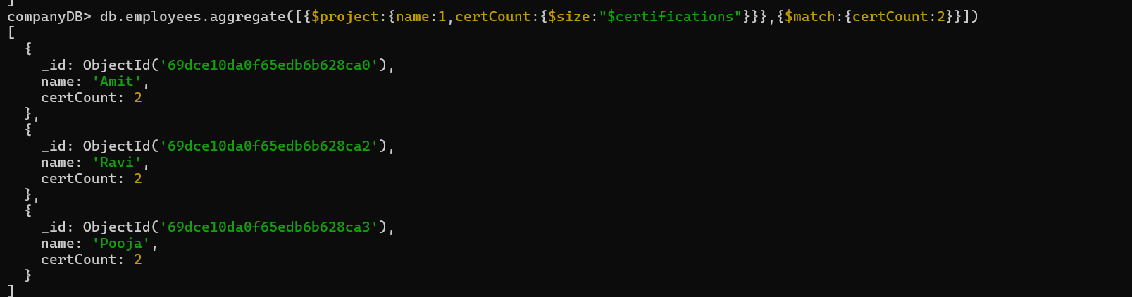
- Add new project to Ravi
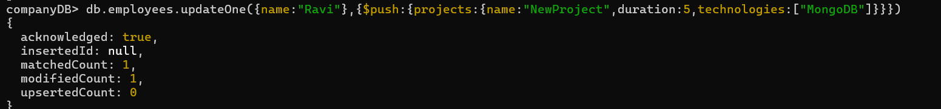
- Increase all salaries by 10% (array update)
--Topic not covered
- Find highest salary of each employee
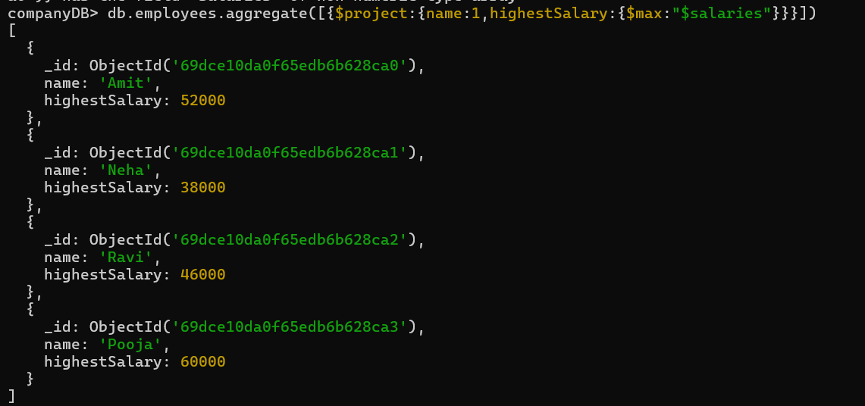

- Find average salary of employees
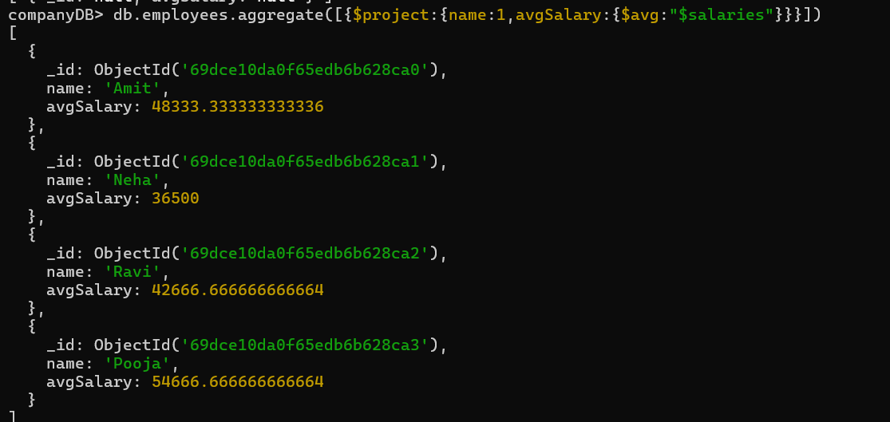
- Filter projects longer than 6 months
--Topic not covered
- Find employees who have any of these skills: Java or Python
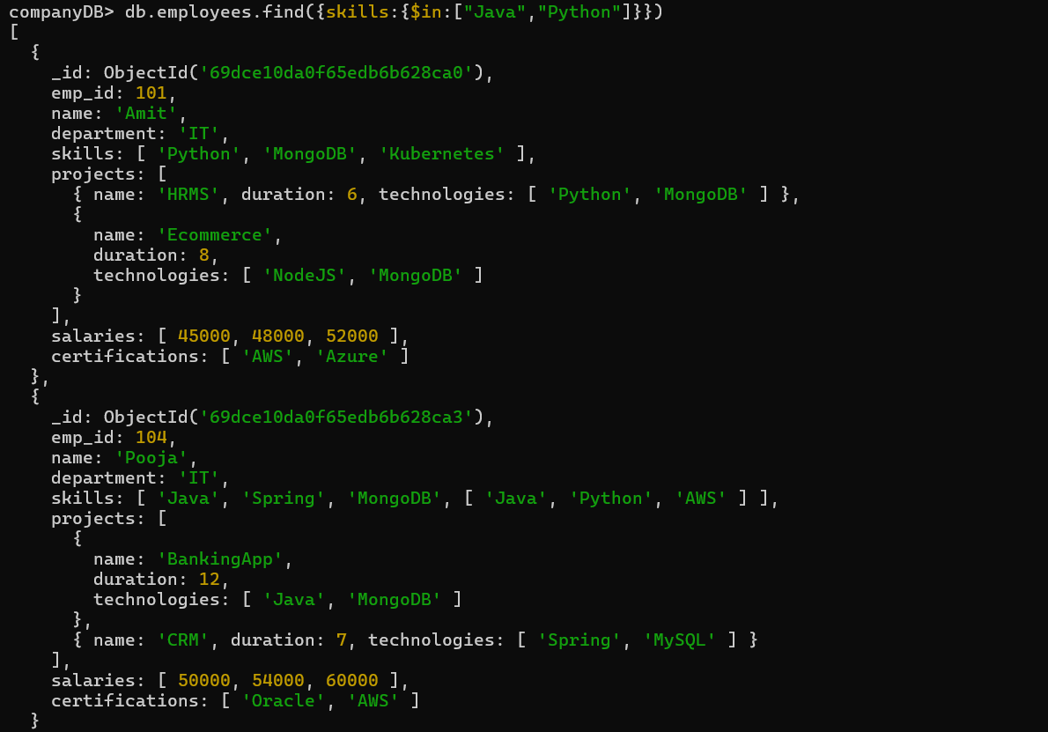

- Remove last salary entry
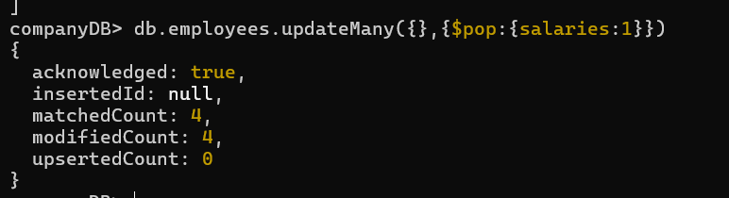
- Remove first salary entry
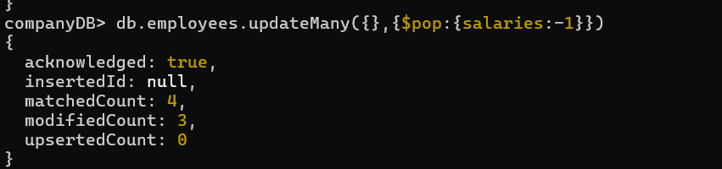
- Sort salaries array
--Topic not covered
- Limit salaries array to last 2 entries
--Topic not covered
- Find total salary paid to each employee
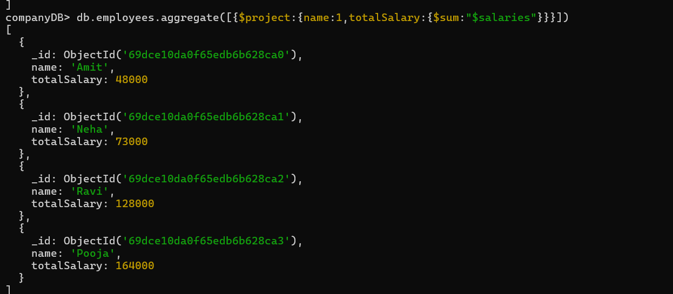
- Convert skills to uppercase
--Topic not covered
- Find employees with more than one project
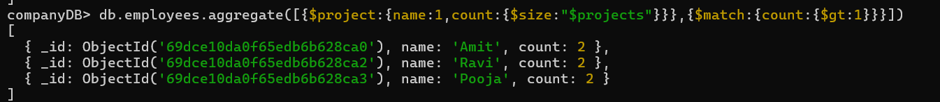

- Count employees per skill
--Topic not covered
- Find employees whose all projects use MongoDB
--Topic not covered

